A REPORT ON DEMONSTRATING HOW GIS TECHNIQUES CAN BE USED TO ASSIST IN ANALYSING ENVIRONMENTAL FEATURES ON A SITE, USING FANSHAWE GATE FARM AS A CASE STUDY

By

MARVIS ESIVUE

STUDENT NUMBER: 32048079

TABLE OF CONTENTS

1. INTRODUCTION---------------------------------------------------------------------------------3
1.1 Purpose of the report------------------------------------------------------------------------- 3
1.2 Context of site-----------------------------------------------------------------------------------3
1.3 Legislation----------------------------------------------------------------------------------------3
1.4 Why is GIS important?------------------------------------------------------------------------4
2. METHODOLOGY--------------------------------------------------------------------------------5
2.1 Topographical analysis------------------------------------------------------------------------5
2.2 Standardized habitat mapping--------------------------------------------------------------5
2.3 Detailed vegetation mapping--------------------------------------------------------------- 5
3. RESULT------------------------------------------------------------------------------------------- 6
3.1 Topographical analysis------------------------------------------------------------------------6
3.1.1 Slope-----------------------------------------------------------------------------------------------6
3.1.2 Aspect-------------------------------------------------------------------------------------------- 7
3.2 Standardized habitat mapping---------------------------------------------------------------9
3.3 Detailed vegetation mapping------------------------------------------------------------- --10
4. DISSCUSSION/ANALYSIS---------------------------------------------------------------------14
5. CONCLUSION------------------------------------------------------------------------------------15
6. REFRENCES---------------------------------------------------------------------------------------15

LIST OF FIGURES

FIGURE 1: Showing the location of Fanshawe Gate Farm
FIGURE 2: showing the slope of Fanshawe gate farm.
FIGURE 3: Showing the Aspect of Fanshawe Gate Farm
FIGURE 4: map of Fanshawe gate farm showing standardized habitat mapping using phase 1 classification techniques.
FIGURE 5: showing the distribution of galium saxatile across one of the fields at Fanshawe gate farm.
FIGURE 6: showing the interpolated output for g_saxatile species using inverse distance weighting for 2004, 2011 and 2019
FIGURE 7: map showing how distribution of g_saxatile has changed between 2004 and 2011
FIGURE 8: showing the mean distribution of g_saxatile for 3 years (2004, 2011 and 2019)
FIGURE 9: showing the standard deviation of g_saxatile for 3 years (2004, 2011 and 2019)
FIGURE 10: showing the reclassified mean for g_saxatile
FIGURE 11: the reclassified standard deviation for g_saxatile
FIGURE 12: showing the combined reclassified mean and standard deviation for g_saxatile using the plus tool

- INTRODUCTION

  - PURPOSE OF REPORT

The purpose of this report is to use GIS techniques and skills to analyze the environmental factors influencing the Fanshawe Gate Farm Site located near Holmesfield. This report will critically demonstrate GIS principles in the context of the environment and most of the techniques will be carried out using the ArcGIS 10.6.1 software. Georeferencing, topographical mapping (to obtain the slope and aspect), standardized habitat mapping using phase1 habitat classification, detailed vegetation mapping to map out the vegetation on the site and using the raster analysis features of GIS to map out the distribution of species across the field with Inverse Distance Weighing (IDW) interpolation techniques are some of the techniques that will be used in this report. GIS can assist in the analyzing of environmental features of an area through the inbuilt analytical tools, this analysis carried out by GIS can help to create an inventory for ecology (list of plants, animals, soil types), which will enable us to evaluate the elements endangering their population. Additionally, we can track the elements using GIS technology to keep an eye on their development (ellipsis drive, 2023).

  - CONTEXT OF SITE

According to (Andrew. J., et al, 2010). Fanshawe Gate Farm is a small and not intensively managed livestock farm. In 2002, most of the farm was included in the Educational Access provision of the Countryside stewardship scheme. Since then, this project has not continued, and the land is now under Environmental Stewardship now. Fanshawe Gate Farm is in Sheffield's southwest near Holmesfield.

  - LEGISLATION
The farm was bought by the current owners in 1992, during that period which it was in bad shape at the time. The owners tried to ensure that the management of the farm is understanding of their strong support for environmental preservation. However, because of their other jobs, the owners had to hire a local farmer to manage the property, which limits their ability to oversee every aspect of management. There are restrictions on the amount of grazing allowed and the use of fertilizers where land has been placed under the Environmental Stewardship program. Since 1992, none of the agreement land has received fertilizer applications. However, in 1992, it was completely limed (calcium carbonate was added to raise the pH).

AN OVERVIEW OF THE STUDY AREA
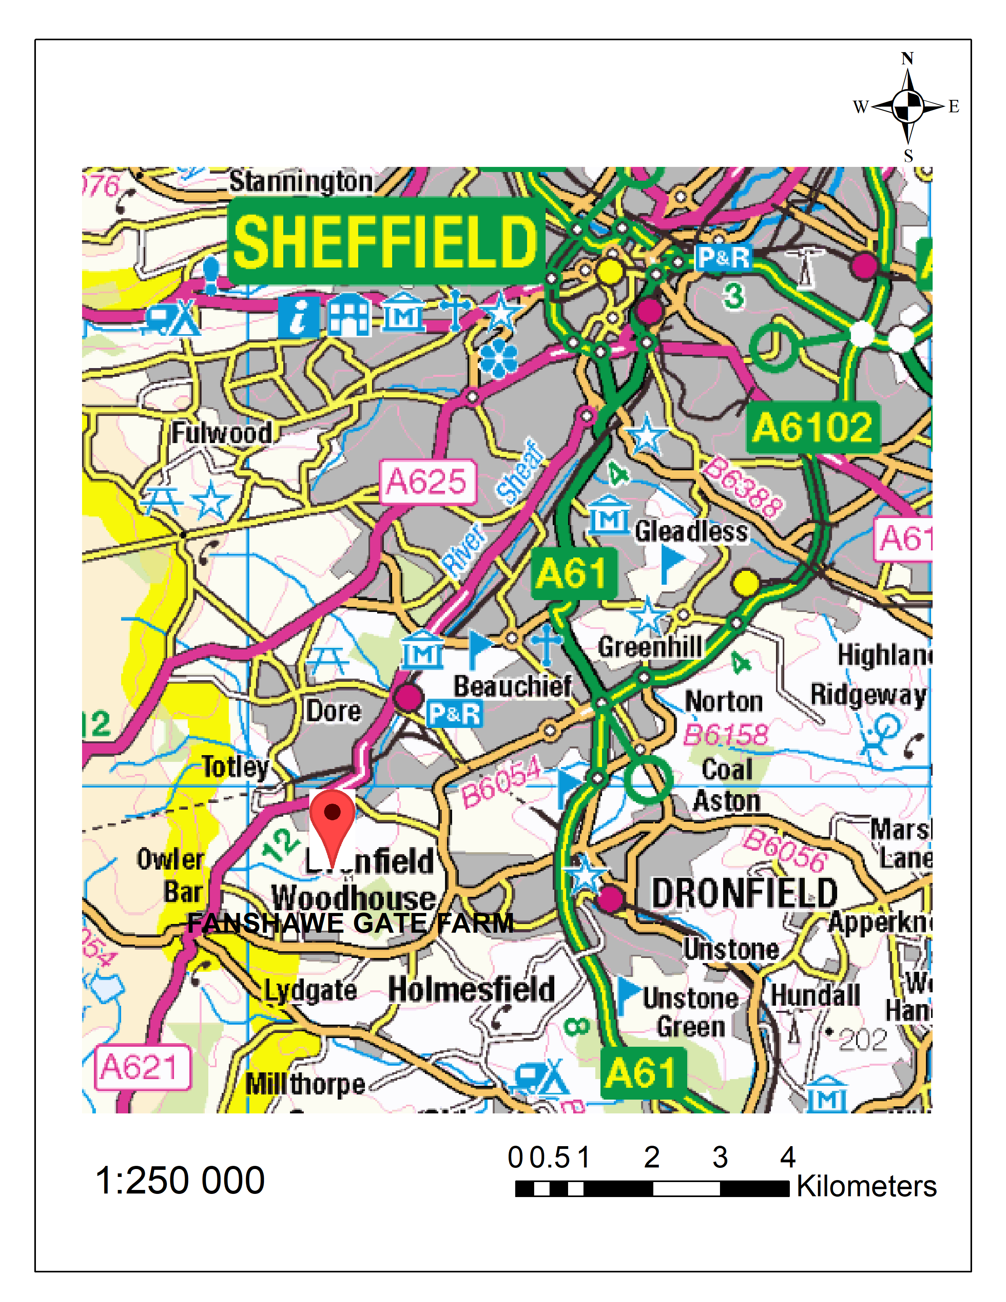
FIGURE 1: Showing the location of Fanshawe Gate Farm
SOURCE: EDINA DIGIMAP (March 2023)
https://digimap.edina.ac.uk

  - WHY IS THE USE OF GIS IMPORTANT?
Our ecological data can be more precise, dependable, and usable with the use of GIS. GIS can be used to show findings and suggestions in real world locations, it can also be used to depict expert maps and in several data formats for easy integration into any project. What makes GIS so crucial? One map in a GIS can display a variety of data types. GIS enables current and historical data to be easily accessed and tracked, which helps in the monitoring of environmental data analysis and improves planning (Mike.D, 2022). To calculate numerous environmental characteristics and conduct impact analysis, it also includes the capability to overlay many components, including slopes, vegetation, threatened species, watersheds, and other issues. General uses of GIS include vegetation mapping (To measure the resource and monitor change), Aerial photography analysis and satellite imagery analysis.

- METHODOLOGY

All the different analysis in this report was carried out using ArcGIS 10.6.1 software. The first analysis carried out was to create a map of the study area (Fanshawe Gate Farm) using backdrop mapping data product with 1: 250 000 raster (Digimap, 2023) and included a location pin.

  - Topographic Analysis
A Topographic analysis in which a map showing the topographical area of Fanshawe gate farm was produced, this was carried out by downloading an OS Terrain 5 DTM raster 250k (Digimap, 2023) of Fanshawe Gate Farm (SK37NW) with a 10 km reference grid using the ordinance survey. We also derived the slope and aspect information from the topography. The purpose of topographic analysis is to understand surface terrain and produce digital maps that depict a simulation of the research region using some GIS tools and procedures after developing a DEM for the study area using field survey methods like as well as contour maps, hill colours, and slope (Habeeb, G., et al, 2021).

2.2. Standardized Habitat Mapping

A Standardized Habitat mapping was carried out using a phase 1 Habitat Classification technique to produce a detailed ecological evaluation of Fanshawe Gate Farm where mapping for various fields was carried out around the boundaries. The georeferenced aerial photography of Fanshawe Gate Farm and Google earth combined with the ecological data available, was used to assist for the mapping to locate areas(fields) that were improved, semi-improved or unimproved. We used the standard palette making sure our symbology is in line with the standard approach for mapping the phase 1 habitats. A rationale for carrying out this technique is that standardized habitat mapping helps us to understand how we can manage a site and it can also tell us how valuable a site is for certain features (JNCC, 2010). It might also help to inform further survey work. The aim of Phase one habitat classification was to systematically classify the different habitats within a given location. It is done to perform a classification tool that can be applied in lots of different settings using standardized habitat types which allows us to draw comparisons across different areas about what habitats are present, and to give us more detail about different species in different habitat to know if they are frequent, abundant, or rare.

2.3. Detailed vegetation mapping

Another tool which was used is the spatial interpolation tool that enables us to use point data to create continuous cover data within a given setting. We do that by generating a continuous surface from specific point location in the data that we have on those specific point locations. The rationale behind this technique is that it is useful for understanding how species distribution occurs within a landscape or how that distribution has changed over time. Other uses of this technique include monitoring of air quality. Spatial interpolation technique is based on the principle of geography that states: everything is related, but near things are more related than further things.

- RESULTS

  - TOPOGRAPHICAL ANALYSIS
For this analysis, we interpreted topographic features using GIS. Slope and aspect are the characteristics examined and interpreted. Understanding the links between ecological processes and physical features is one of this analysis's main objectives.

    - slope
A raster surface's steepness at each cell is determined via the Slope tool. The slope value determines how steep the terrain is, the lower the slope value, the flatter the ground (Esri, 2023). Figure 2 below, shows a map of the slope value of Fanshawe Gate Farm, looking at the map, we can see that the slope value of the area ranges from 3.80 to 45.05, with the lower areas in green having a flatter terrain and the higher areas in red having a much steeper terrain. The areas in yellow with 18.20– 20.79 slope value shows terrain that are higher than the green areas and less steep than the areas in red.

One limitation of the slope tool is that the Slope tool fits a plane to the nine local cells, although a plane might not accurately describe the landscape and might hide or exaggerate interesting natural changes. Unlike the slope tool, the surface parameters tool adapts a surface to the vicinity of cells rather than a plane, giving the landscape a more realistic fit.
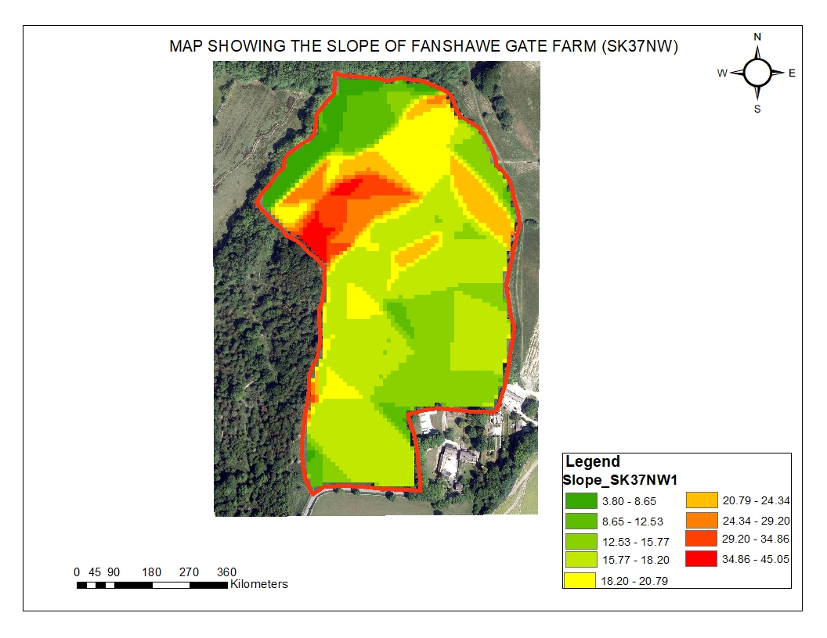
FIGURE 2: SHOWING THE SLOPE OF FANSHAWE GATE FARM
SOURCE: Digimap OS Collection
http://digimap.edina.ac.uk

3.1.2. aspect
The aspect tool in GIS adapts a surface to the vicinity of cells rather than a plane, giving the landscape a more realistic fit. Aspect shows the direction of the maximum rate of value change from one cell to its neighbors, which is downward. The direction of the slope can be compared to aspect. Looking at Figure 3 below, we can see that the aspect is calculated clockwise, beginning at 0 degrees north and comes back as 360 degrees north again. A limitation to the aspect is that The Aspect tool applies a plane to the nine local cells, however a plane might not be a useful way to describe the terrain because it might hide or exaggerate interesting natural differences. Instead of fitting a plane to the vicinity of cells, the Surface Parameters tool does so in a way that is more akin to how the terrain would be.

The Surface Parameters tool allows for window sizes ranging from 3 by 3 to 15 by 15 cells, whereas the Aspect tool computes the value using a 3 by 3 window of cells to properly represent land surface dynamics, larger window widths are helpful when used with high resolution elevation data.
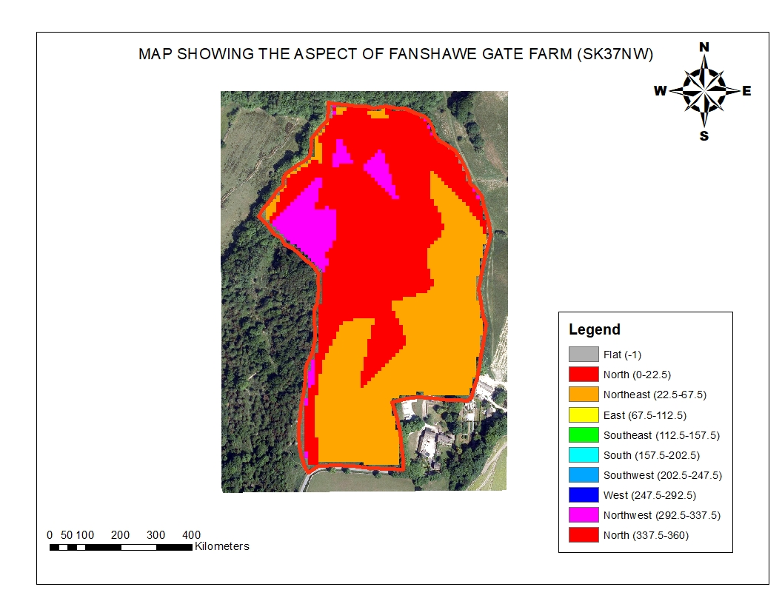
FIGURE 3: Showing the Aspect of Fanshawe Gate Farm
SOURCE: Digimap OS Collection
http://digimap.edina.ac.uk
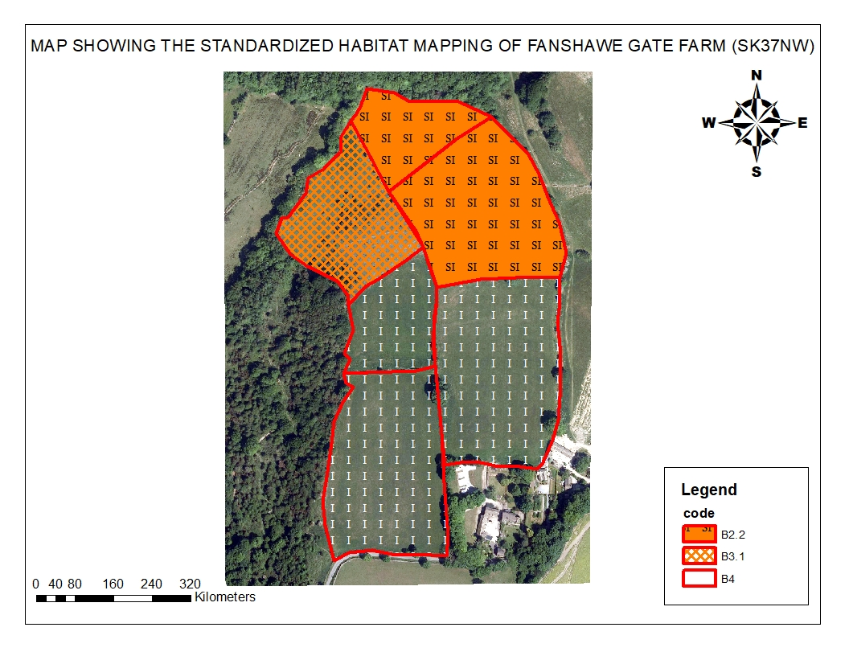
3.2 STANDARDIZED HABITAT MAPPING
FIGURE 4: MAP OF FANSHAWE GATE FARM SHOWING STANDARDISED HABITAT MAPPING USING PHASE 1 CLASSIFICATION TECHNIQUES.
SOURCE: AUTHORS ANALYSIS

The standardized habitat mapping was carried out using the phase 1 classification techniques. The classification was done based on the habitats in the fields and the boundaries around the site. The ariel photograph of Fanshawe Gate Farm and google earth was used to assist with the standardized habitat mapping. The standard palette of the phase 1 habitat classification was also used, and I made sure that the symbology matches with the standard approach to mapping the habitat. Georeferencing was carried out on the Fanshawe Gate Farm image as it helped to provide ariel photography for the base map. Observation was done for the species present, and I looked at specific indicators for degrees of improvement using the phase 1 technique whether it was improved, semi-improved or unimproved, I also decided if each field was calcareous, acidic, or neutral. Looking at the figure 4 above, the field in the northern areas are classified as semi-improved neutral grassland, this conclusion was arrived at after looking carefully at the site on google earth, this decision was made because semi-improved grassland is usually bright green and have +/- uniform texture. One area which there might be a Limitation for the standardized habitat mapping is the errors that can occur when trying to georeference or digitize. Making errors while digitizing is hardly something anybody can avoid, and this can affect the accuracy of the analysis. Another limitation of the phase 1 habitat technique to look at, is that it might be quite broad. For example, you might have a woodland that’s semi-natural that classes as one single feature in a habitat as a abroad leaf woodland that’s semi-natural, but it might have lots of sub communities within it that wouldn’t get picked up within the phase one survey. Another limitation observed about the phase 1 habitat survey is that it does not allow us to evaluate the condition of the habitats.

  - DETAILED VEGETATION MAPPING
Figure 5 below shows the abundance of the distribution of heath bedstraw on one of the seven fields in Fanshawe Gate Farm in 2004. A choropleth map (figure 5) was created to explore the distribution of heath bedstraw (Galium saxatile) across one of the fields at Fanshawe Gate Farm in 2004. This is helpful; however, it simply shows fixed points and doesn't let us examine data trends. Because it doesn't maximize the use of our data, the interpolation technique must be used to examine data trends. I carried out the interpolation technique on 3 different years for the same field for more analysis.

After going through the various interpolation techniques such as inverse distance weighting, Natural Neighbor, and spline. Inverse distance weighting was the interpolation technique selected to be more justifiable for the data. Figure 6 shows the result of the interpolated output using inverse distance weighting on the same field for 3 different years. It is simple and effective with dense data. Interpolated values lie within the range of the input values. The Interpolation was also done to explore changes in the abundance and distribution of heath bedstraw (Gallium saxatile) to compare the distributions for 3 different years (FIGURE 6).

More interpolation was also carried out (FIGURE 7) to show the change in the distribution of G_saxatile between 2004 and 2011. The inverse distance weighting can be run through Geostatistical Wizard. We may examine some of the data that support the interpolation strategy by using Geostatistical Wizard, which is an advantage. We can also adjust the model's parameters to see how the results of the statistics displayed change. This is useful for defending the strategy used.

MAP SHOWING THE DISTRIBUTION OF GALIUM SAXATILE ACROSS ONE OF THE FIELDS AT FANSHAWE GATE FARM in 2004.
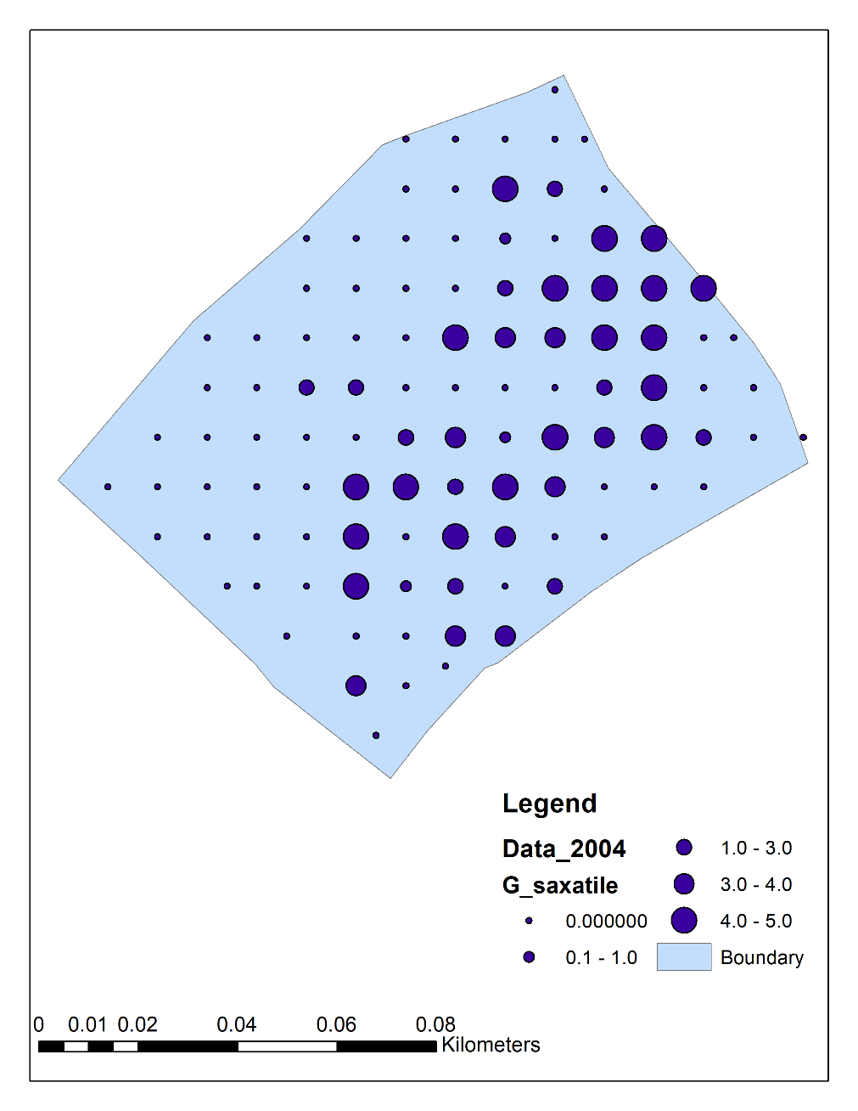
FIGURE 5: SHOWING THE DISTRIBUTION OF GALIUM SAXATILE ACROSS ONE OF THE FIELDS AT FANSHAWE GATE FARM.
SOURCE: AUTHORS ANALYSIS

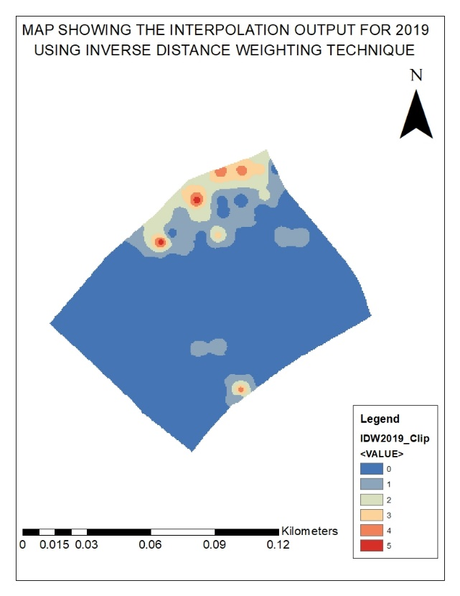
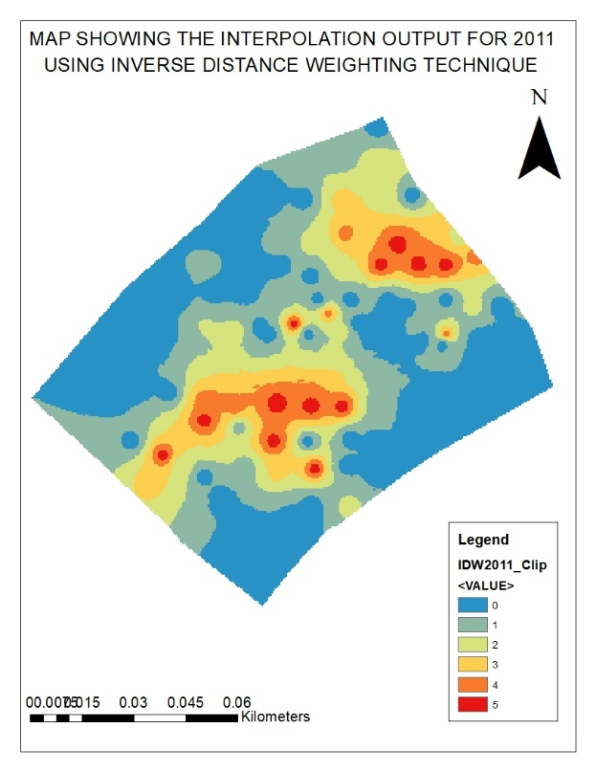
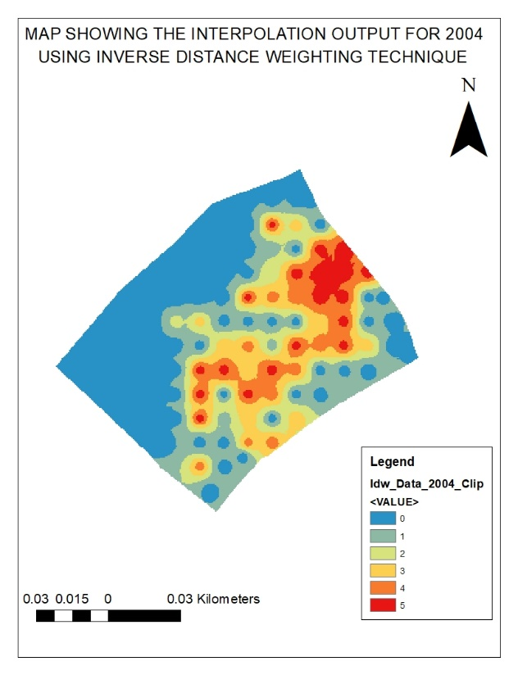
MAPS SHOWING THE INTERPOLATED OUTPUT OF G_SAXATILE SPECIES ON ONE OF THE FIELDS IN FANSHAWE GATE FARM FOR 3 YEARS (2004, 2011 AND 2019)

FIGURE 6: SHOWING THE INTERPOLATED OUTPUT FOR G_SAXATILE SPECIES USING INVERSE DISTANCE WEIGHTING FOR 2004, 2011 AND 2019
SOURCE: AUTHORS ANALYSIS

MAP SHOWING HOW DISTRIBUTION OF G_SAXATILE HAS CHANGED BETWEEN 2004 AND 2011
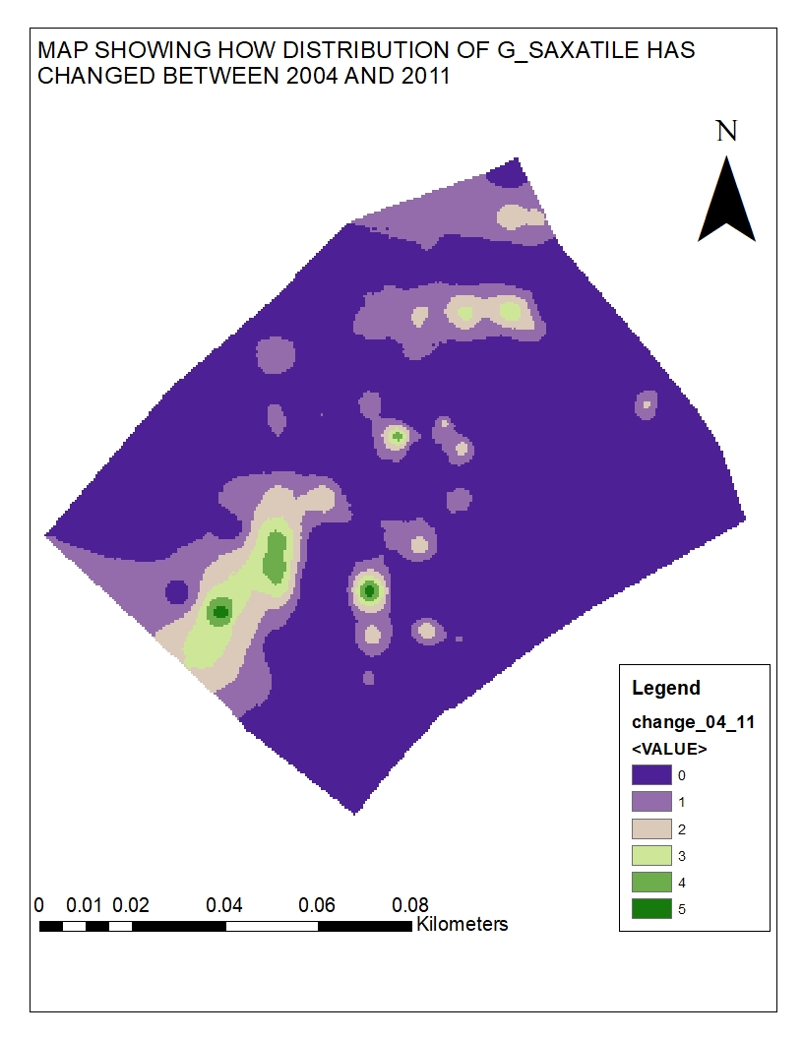
FIGURE 7: MAP SHOWING HOW DISTRIBUTION OF G_SAXATILE HAS CHANGED BETWEEN 2004 AND 2011
SOURCE: AUTHORS ANALYSIS

Further analysis was carried out such as the mean (FIGURE 8), standard deviation (FIGURE 9), which was reclassified according to different classes (FIGURE 10 AND 11).
The mean analysis was carried out to determine if the levels remained high, low or if there is any change. It is possible to interpret changes in the abundance of species by
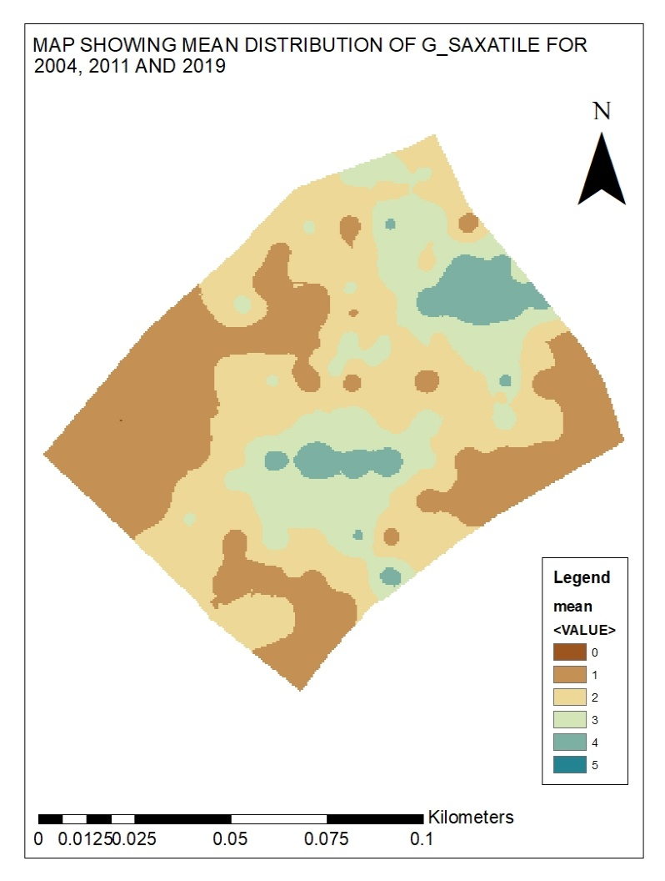
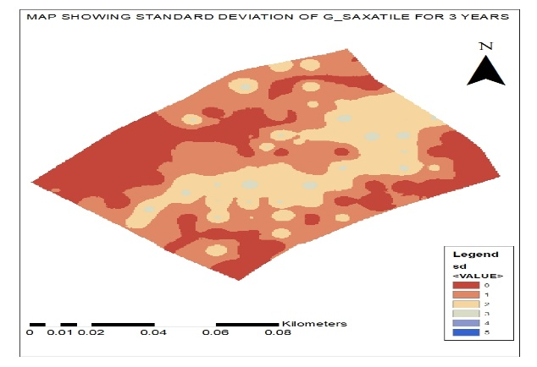
visual comparison of the raster surfaces. The standard deviation was carried out to find the locations that changed and the location that remained unchanged.

FIGURE 8 FIGURE 9

FIGURE 8 AND 9: SHOWING THE MEAN DISTRIBUTION AND STANDARD DEVIATION OF G_SAXATILE FOR 3 YEARS (2004, 2011 AND 2019)
SOURCE: AUTHORS ANALYSIS

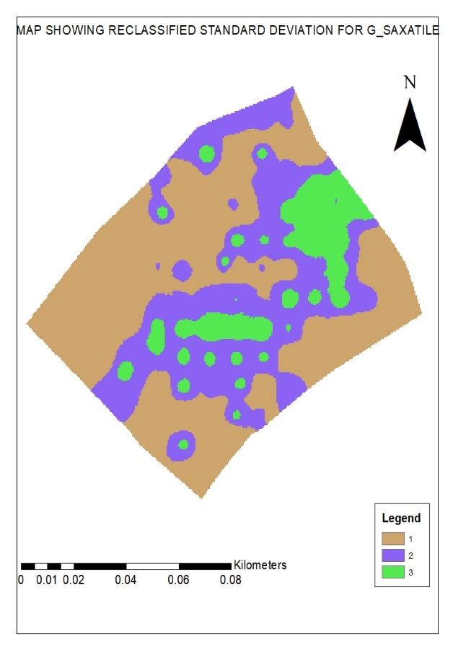
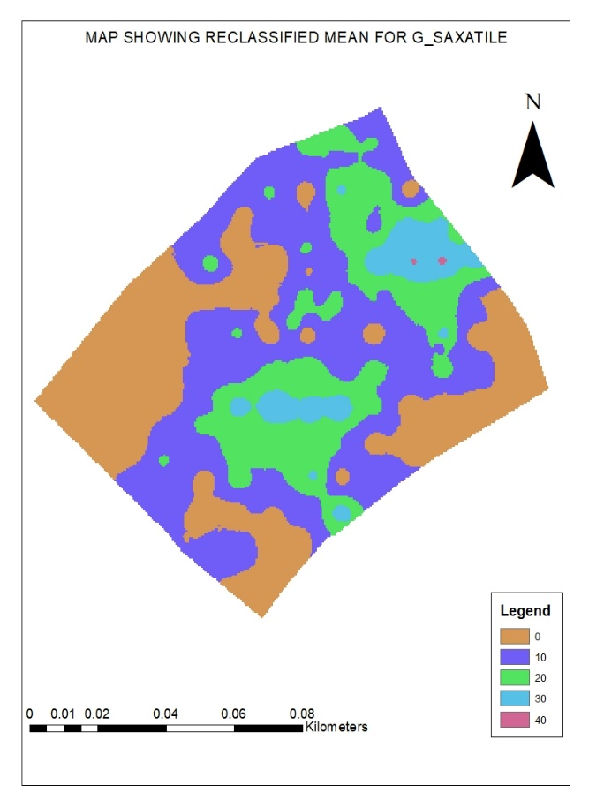

Figure 10 Figure 11

FIGURE 10 AND 11: SHOWING THE RECLASSIFIED MEAN AND THE RECLASSIFIED STANDARD DEVIATION FOR G_SAXATILE
SOURCE: AUTHORS ANALYSIS

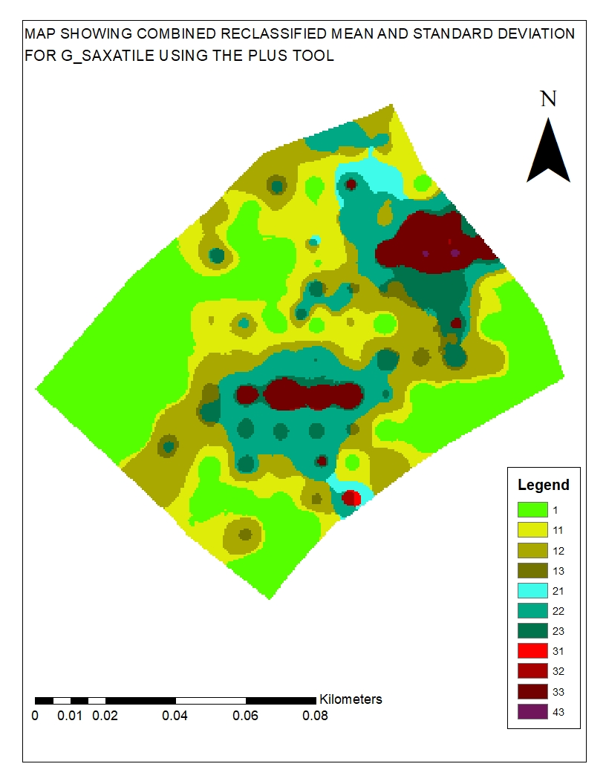
FIGURE 12: SHOWING THE COMBINED RECLASSIFIED MEAN AND STANDARD DEVIATION FOR G_SAXATILE USING THE PLUS TOOL
SOURCE: AUTHORS ANALYSIS

- DISCUSSION/ANALYSIS

The slope output is frequently displayed as a raster layer, where each pixel represents the slope in terms of a percentage. A colour ramp was used to illustrate this layer, with warmer hues like red and orange denoting steeper slopes and cooler hues like blue and green denoting flatter slopes. A farm manager or planner can identify parts of the farm that are inappropriate for operations like grazing, cropping, or development using this slope data. This knowledge can assist farmers in implementing better soil management practices and minimizing adverse environmental effects because steep slopes can also be prone to soil erosion. Overall, the Fanshawe Gate Farm's slope output yields useful information for land-use. The analysis shows how GIS tools can be used to support the examination of a site's environmental aspects. The construction of a map of the location using GIS software enables the overlay of data to reveal regions of interest. Making educated judgements concerning the management of the land is then possible using this information. Several interesting areas in Fanshawe Gate Farm locations were found through study. These included regions with significant soil erosion, which were mostly found on inclining terrain. Additionally, the investigation revealed places with little vegetation cover, mostly in low-soil-quality areas. The research also pinpointed regions with high water runoff, which were primarily found in flat terrain with impermeable soil.

The direction that a particular spot on the farm's topography faces is displayed in the aspect analysis report for Fanshawe Gate Farm. Like slope information, this aspect data is derived from digital elevation models (DEMs) that have been GIS-processed. Each pixel in the layer records the slope's compass orientation for that place in the aspect. As an illustration, a pixel facing north will have a compass direction of 0 degrees, whereas a pixel facing south will have a compass direction of 180 degrees. A colour ramp was used to symbolize the aspect output, with different colours standing for different aspects. North-facing slopes are depicted on the colour ramp as red, and south-facing slopes as sky blue.

The analysis of the standardized habitat mapping for Fanshawe Gate Farm depicts the various types of habitats that are present there. The result, which is based on spatial data gathered during a habitat survey or study, is obtained using GIS software.
The outcome of standardized habitat mapping is often displayed as a raster overlay with each pixel representing a different habitat category. The phase 1 approach was used to classify the pixel values. The results were displayed using a colour map that depicts the many types of habitats found on the farm. These results displayed dominant environments like grasses. It is possible to compare the habitat coverage of various agricultural areas or over various durations using standardized habitat mapping. standardized habitat mapping helps to evaluate patterns or prospective habitat decline. The standardization of mapping guarantees that the analysis outcomes for various geographical areas utilizing the same standards are consistent.

Overall, the Fanshawe Gate Farm standardized habitat mapping output using Gis offers useful data for planning land use, managing natural resources, planning for conservation, and evaluating the environmental effects of land-use activities.

- CONCLUSION

The investigation of Fanshawe Gate Farm concludes by showing how GIS tools can be used to support the analysis of environmental factors on a site. Using GIS software makes it possible to identify regions of interest, which may subsequently be utilized to inform land management decisions. The farm may be handled sustainably and environmentally friendly thanks to the knowledge gathered from this investigation.

- REFRENCES

Andrew. J. (2010). GIS and Environment Site Information

ESRI. (2023). How Slope Works.
Retrieved from: https://pro.arcgis.com/en/pro-app/latest/tool-reference/spatial-analyst/how-slope-works.htm

Ellipsis drive (2023). How Can We Use GIS for Environmental Preservation?
Retrieved from: https://ellipsis-drive.com/blog/how-gis-helps-to-save-the-environment/#What%20is%20the%20importance%20of%20GIS

Habeeb, G., et al. (2023) Topographic and Hydrologic Analyses using Geographic Information System (GIS): A Case Study of Karbala City-Iraq.
https://doi.org/10.1051/e3sconf/202131804006

JNCC. (2010). Handbook for Phase 1 habitat survey: A technique for environmental audit. ISBN: 978-0-86139-636-8
Retrieved from: https://data.jncc.gov.uk/data

Marvis, E. (2023). Fanshawe Gate Farm. PDF map, Scale 1:2500, OS MasterMap, November 2019, Ordnance Survey, using Digimap Ordnance Survey Collection, Retrieved from: https://digimap.edina.ac.uk/
Mike.D. (2022). How GIS Can Help In Managing The Environment
Retrived from: https://mgiss.co.uk/managing-the-environment/

UKEssays.(2018). Fanshawe Gate Farm Individual Report Geography Essay. Retrieved from https://www.ukessays.com/essays/geography/fanshawe-gate-farm-individual-report-geography-essay.php?vref=1

